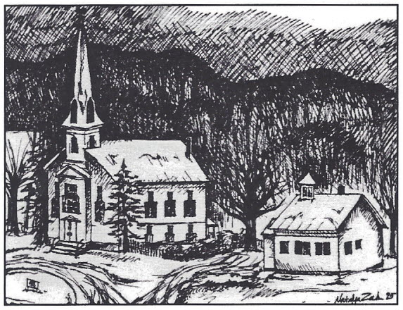
TOWN OF WOODBURY
1672 VT RT 14
P.O. BOX 10
WOODBURY, VERMONT 05681
E-mail: clerk@woodburyvt.org
Phone: 802-456-7051
FAX: 802-456-8834
Web Site woodburyvt.org

Town of Woodbury Request for Bid
Three (3) Year Contract for Winter Sand

The Town of Woodbury is soliciting bids for 10,000 cubic yards of Winter Sand over the next three years – 2,000 yards for 2022-2023, and 4,000 yards for the following two winter seasons (2023-4 and 2024-5).

The sand shall contain 3/8”to 1/2” stone minus screened sand and meet or exceed State and American Association of State Highway and Transportation Officials (AASHTO) specifications. (Please see the attached specifications sheet on page 3.) The Town may request a sand sample to facilitate the bid award process.

The bid should specify two prices: a price if delivered by the vendor to the Town Highway Garage at 524 Dog Pond Road, Woodbury and a price if picked up at the pit. Please include the applicable discount percentage if a total annual invoice is prepaid.

Additional information may be obtained by contacting Chuck Batchelder, Road Commissioner at cb27quarryroad@gmail.com. Bid forms and bidding instructions are available by contacting the Town Office by phone, 802.456.7051, or by email treasurer@woodburyvt.org. or on the town web site woodburyvt.org at Records/Requests for Proposals.
Bidders must have proper liability insurance in the minimum amount of $1,000,000. Certificates of Insurance with the Town listed as certificate holder should be forwarded with the bid.
Bids shall be in a sealed envelope, clearly marked “Bid for Winter Sand” and delivered to the Town Office by noon on July 7, 2022. Bids will be opened at the Select Board meeting of July 11, 2022. The Town reserves the right to reject any or all bids, and to grant the bid that is deemed to be in the best interest of the Town.

All bids must in submitted either in person or by mail as specified in the header. No faxed or emailed bids can be accepted.

INSURANCE:
Worker’s Compensation: The successful bidder will carry Worker’s Compensation insurance in accordance with the Laws of the State of Vermont.
General Liability: The successful bidder will carry General Liability Insurance including but not limited to:
Premises
Products and Completed Operations
Personal Liability
Contractual Liability
Personal Injury Liability
The policy shall be on an occurrence form and limits shall not be less than:
$1,000,000 Per Occurrence
$1,000,000 General Aggregate
$1,000,000 Products/Completed Operations Aggregate
$ 50,000 Fire/ Legal/Liability

Automotive Liability: The Party shall carry automotive liability insurance covering all motorized vehicles, including hired and non-owned coverage, used in connection with the project. Limits of coverage shall not be less than: $1,000,000 combined single limit.

__/s/___Peter Peltz___________ Peter Peltz, Town of Woodbury Select Board Chair
(Duly Authorized Representative of the Town of Woodbury)

Specifications for Winter Sand

Winter Sand shall be clean, hard, screened sand, uniformly graded from coarse to fine, and shall be reasonably free from silt, loam, clay, or organic matter. The sand shall be obtained from approved sources and shall meet or exceed the following requirements, including passing a Ph. test.

Sieve Designation % by Weight Passing Square Mesh Sieves

Up 3/8” | 100
No. 4 | 90-100
No. 100 | 2-10

- The material will be sampled by the Highway Road Crew and tested.

- Product Availability:

  - Delivery Option:
      - No later than September 12, 2022
    - No later than September 11, 2023
    - No later than September 16, 2024
    - Picked up at the Pit
      - Available by August 8, 2022
    - Available by August 7, 2023
    - Available by August 12, 2024

The Town reserves the right to contract with a third-party hauler to haul the product to the Town site.

- The Town reserves the right to test the product at any time and take appropriate action if the product is deemed deficient including cancelation of the contract or refusal of any delivery.

- The successful bidder shall indemnify and hold harmless the Town, its officials, agents, and employees from any loss or liability which may result from claims of injury to persons or property from any cause arising out of or during the delivery of product to the Town.

- The Town reserves the right to purchase any product from any vendor other than the accepted bidder.

Town of Woodbury
Town Office Building
1672 Vermont Route 14, P.O. Box 10
Woodbury Vermont 05681

Winter Sand Bid 10,000 Cubic Yards Over Three (3) Winter Seasons
(2,000 in 2022-23 and 4,000 in 2023-24 and 2024-25)

Bids are to be submitted in a sealed envelope, clearly marked “Bid for Winter Sand” and delivered in person or by U.S. Mail. No faxes or emails will be accepted.

Bids are due no later than 12 P.M. - Noon on July 7, 2022

Name of Bidder: _____________________________________________

Bidder’s Address: ____________________________________________

Bidder’s Email Address: __________________________________________________________

Bidder’s Phone Number: ______________________________________

Bid Amount Delivered: _________________________________ per Cubic Yard Delivered

Bid Amount at the Pit: __________________________________ per Cubic Yard at the Pit

Applicable Discount Percentage: ________________%

Signature of Bidder:

